Chapter 2, Solution 42

(a) R_{ab} = 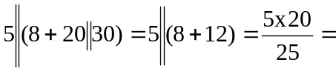 4 Ω

(b) R_{ab} = 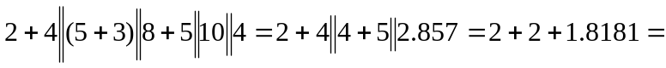 5.818 Ω

